spark streaming

Overview
Spark Streaming enables real-time data processing. A common demo source is a TCP socket, which streams text data for processing. This is useful for learning streaming concepts but not recommended for production (use Kafka or files instead).

Prerequisites
- Apache Spark installed (preferably Spark 3.x).
- Python or Scala environment.
- Netcat (nc) or similar tool for socket simulation.
- Java and Hadoop dependencies configured.

Architecture
- Socket Source → Spark Streaming Engine → Transformations → Sink (Console, Files, DB).
- Structured Streaming uses DataFrame/Dataset API and supports exactly-once semantics with checkpointing.
Start a socket server and send your CSV lines and output is generating with batch intervals.
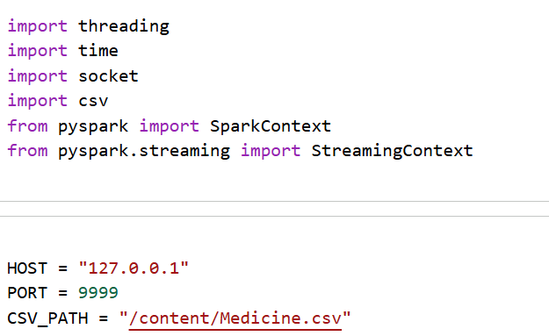
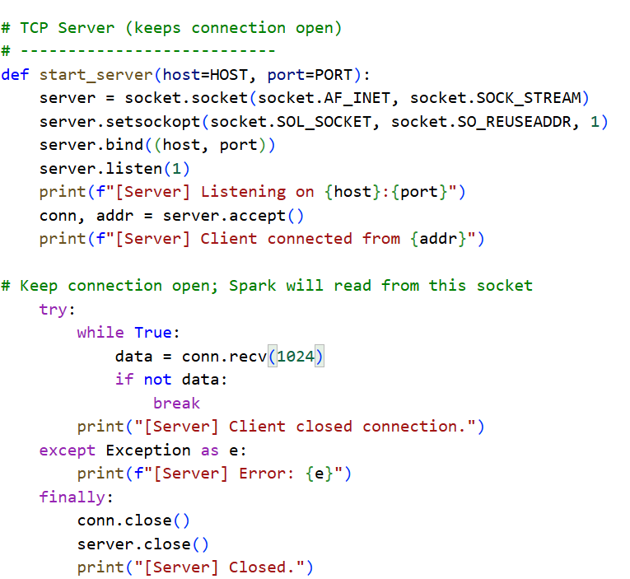
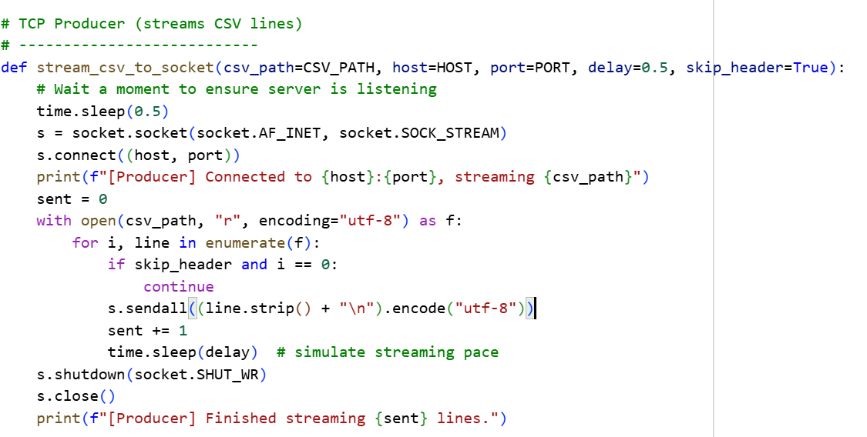
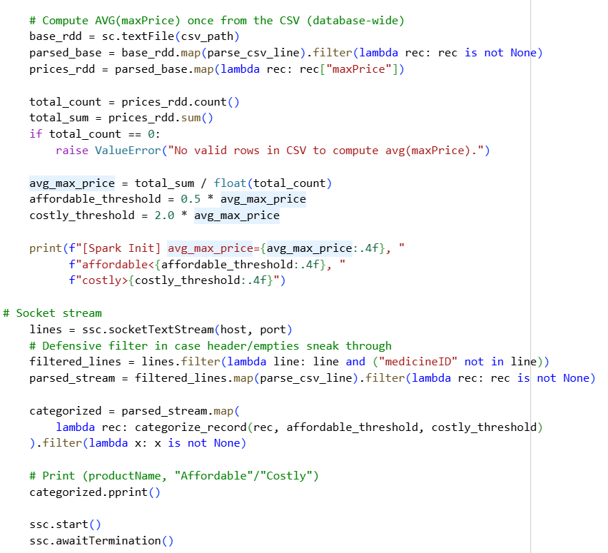
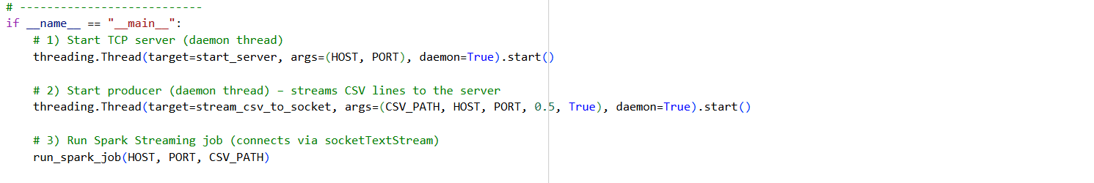

Output:
